Climate impact on Groundwater Level
Analysis Report

Power BI Dashboard Report using Python Visuals
This analysis reveals a clear nationwide pattern: our groundwater levels are level_diff and district_code by station_name that major agricultural and rapidly urbanizing states are extracting water much faster than natural rainfall can replenish it. While seasonal monsoons provide temporary relief—causing the water table to rise slightly during late-summer months—the long-term multi-year trend is moving steadily downward.

Charts Used in Dashboard
Column chart : state_code by longitude and latitude
Scatter chart : level_diff and district_code by station_name
Line chart : level_diff by Year, Quarter, Month and Day
Pie chart : currentlevel by latitude
Area chart : longitude, and atitude, and state id by Year
Kpi : level_diff and Min Level by date
Douut chart : district_code and latitude by Year

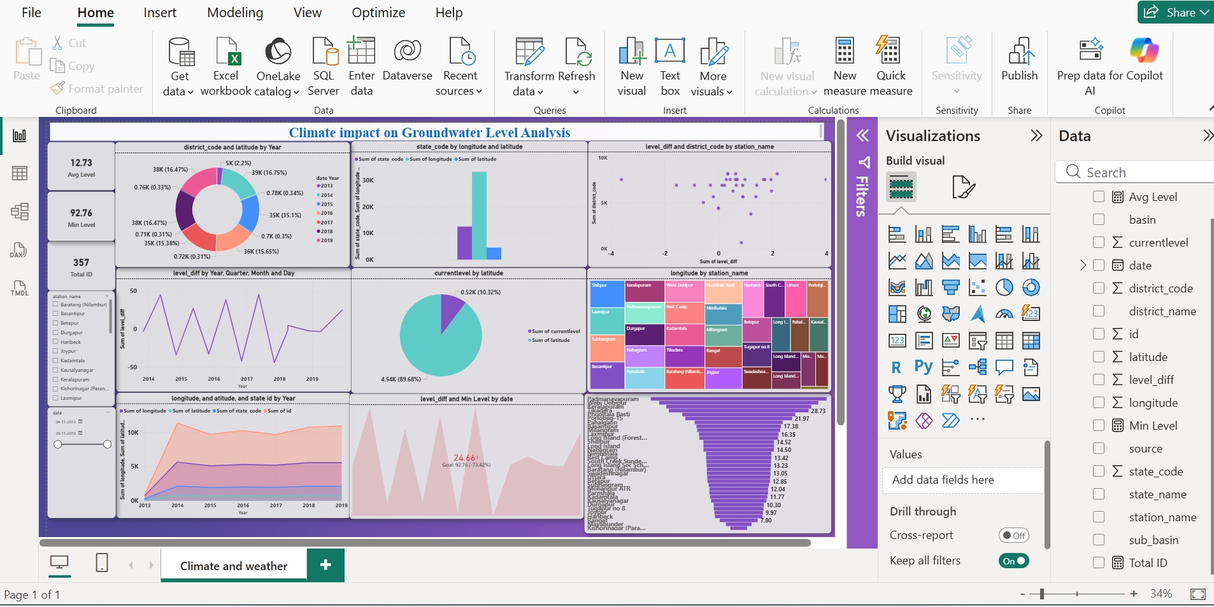

1. Summary of Findings
- The Data: Analyzes 34 active stations in North and Middle Andaman (2013–2019) tracking water depth and change .
- General Baseline: The area has a healthy overall average water depth of 1.46 meters. After monsoons, it fills up nearly to the top (0.03 meters).
- Extreme Seasonal Changes: During dry summer months, water plummets as deep as 5.65 meters. The data swings wildly, dropping by up to 5.07 meters in the summer but recovering by up to 5.25 meters during heavy rains.

2. Key Insights
- Hidden Danger Hotspots: While the 1.46m average looks safe, looking closer reveals that many stations plunge dangerously deep (past 5 meters) during summers. Averages hide local water crises.
- Aquifer Volatility: A high fluctuation change standard deviation (1.65 meters) means the local ground behaves like a temporary sponge—it fills quickly but dries out just as fast.
- Rainfall Dependency: The lowest water levels happen right before the rainy season. If a monsoon is ever delayed by even a month, multiple stations will completely run dry.

3. Recommendations for Decision-Making
- Zoning & Extraction Freezes: Use the dashboard to automatically freeze new commercial tube-well drilling within a 5km radius of any station whose depth drops past 4.5 meters.
- Build Sub-Surface Monsoon Traps: Build small check-dams and recharge tanks around the specific stations that show heavy summer depletion but slow monsoon recovery.
- Dynamic Summer Water Pricing: Move large businesses (like tourism facilities or factories) to a tiered pricing model where water costs more in the dry season when aquifers are lowest.

4. Final Story with the Dashboard
- The Visual Flow: When looking at the dashboard, your eyes read the Top KPI Cards from left to right, showing a massive scope of 34 stations but a very safe 1.46m average depth.
- The Twist: However, looking down at the 2-Color Scatter Chart, the illusion breaks. The high-contrast Teal (Safe) and Coral/Red (Critical) theme immediately pulls the viewer’s eyes to bright red warning dots dipping toward the dangerous 5.65m mark.
- The Takeaway: The dashboard transforms passive historical numbers into a real-time defense map. It tells leaders exactly which neighborhoods are drying out during the summer, allowing them to step in with targeted policies before a seasonal shortage becomes permanent.

